JUMP UP!™ WITH PATTY HALL

OASIS FAMILY TIME MUSIC WORKSHOP

ROBINSONS-MAY -- 280 EAST VIA RANCHO PKWY. -- ESCONDIDO, CA
SATURDAY, JUNE 18, 2005
10:00 AM – 12 NOON

 

Come celebrate making music (and RAGGEDY ANN AND ANDY’S 90th and 85th birthdays)!

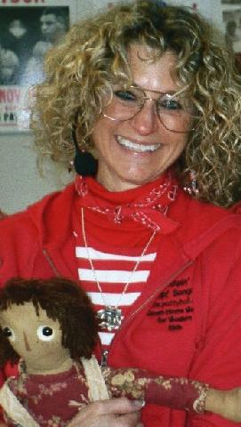
Author-singer-songwriter
PATTY HALL
will present her JUMPIN’ UP!™ SONGS & STORIES
at this intergenerational workshop presented as part of the
OASIS INTERGENERATIONAL CONCERT SERIES.

PATTY will perform her traditional and original
JUMPIN’ UP!™ SONGS

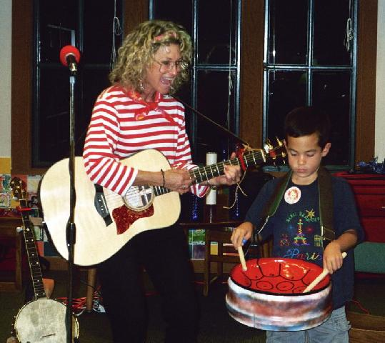

And you’ll get to sing along, dance, and even join in on some special down-home instruments Patty brings with her.

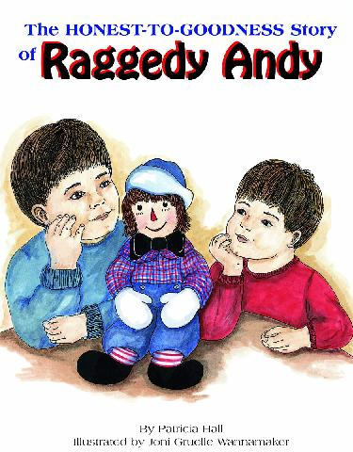
She’ll also read from her newest book, THE HONEST-TO GOODNESS STORY OF RAGGEDY ANDY (the story of where Raggedy Andy really came from!).

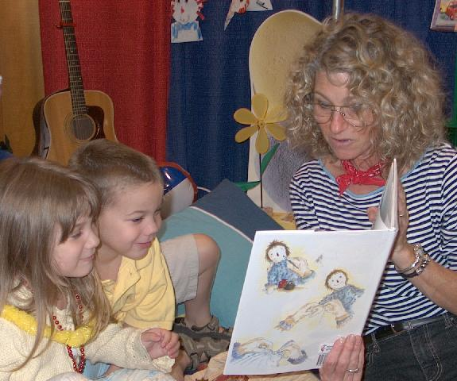So, tune up your singing voice, grab YOUR favorite doll or bear, and come on down to OASIS to celebrate!
A book signing will follow the program.

For more info call
760-480-9400
Or visit www.pattyhall.com 